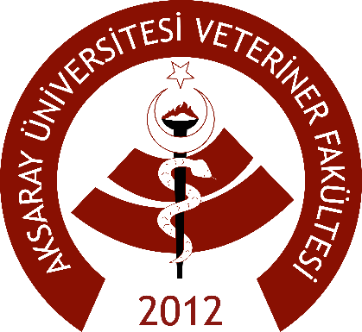

**List of Bilateral Agreements**

|  |  |  |  |  |
| --- | --- | --- | --- | --- |
| # | **Country** | **ERASMUS Code** | **Name of Institution** | **Subject Area** |
| [1](http://erasmusanlasma.aksaray.edu.tr/) | LATVIA | [LV JELGAVA01](http://erasmusanlasma.aksaray.edu.tr/public/ogrenci/antlasma/28) | [LATVIA UNIVERSITY OF AGRICULTURE](http://erasmusanlasma.aksaray.edu.tr/public/ogrenci/antlasma/28) | Veterinary Medicine |
| [2](http://erasmusanlasma.aksaray.edu.tr/) | [SLOVENIA](http://erasmusanlasma.aksaray.edu.tr/public/ogrenci/antlasma/61) | [SI LJUBLJA01](http://erasmusanlasma.aksaray.edu.tr/public/ogrenci/antlasma/61) | [UNIVERSITY OF LJUBLJANA](http://erasmusanlasma.aksaray.edu.tr/public/ogrenci/antlasma/61) | Veterinary Medicine |
| [3](http://erasmusanlasma.aksaray.edu.tr/) | [ROMANIA](http://erasmusanlasma.aksaray.edu.tr/public/ogrenci/antlasma/82) | [RO BUCURES12](http://erasmusanlasma.aksaray.edu.tr/public/ogrenci/antlasma/82) | [UNIVERSITY OF AGRONOMIC SCIENCES AND VETERINARY MEDICINE OF BUCHAREST](http://erasmusanlasma.aksaray.edu.tr/public/ogrenci/antlasma/82) | Veterinary Medicine |
| [4](http://erasmusanlasma.aksaray.edu.tr/) | [SLOVAKIA](http://erasmusanlasma.aksaray.edu.tr/public/ogrenci/antlasma/84) | [ST NITRA02](http://erasmusanlasma.aksaray.edu.tr/public/ogrenci/antlasma/84) | [SLOVAK UNIVERSITY OF AGRICULTURE IN NITRA](http://erasmusanlasma.aksaray.edu.tr/public/ogrenci/antlasma/84) | Veterinary Medicine |
| [5](http://erasmusanlasma.aksaray.edu.tr/) | [POLA](http://erasmusanlasma.aksaray.edu.tr/public/ogrenci/antlasma/122)ND | [PL LUBLIN04](http://erasmusanlasma.aksaray.edu.tr/public/ogrenci/antlasma/122) | [UNIVERSITY OF LIFE SCIENCES in LUBLIN](http://erasmusanlasma.aksaray.edu.tr/public/ogrenci/antlasma/122) | Veterinary Medicine |
| [6](http://erasmusanlasma.aksaray.edu.tr/) | [CZECH REPUBLIC](http://erasmusanlasma.aksaray.edu.tr/public/ogrenci/antlasma/123) | [CZ BRNO 06](http://erasmusanlasma.aksaray.edu.tr/public/ogrenci/antlasma/123) | [UNIVERSITY of VETERINARY and PHARMACEUTICAL SCIENCES BRNO](http://erasmusanlasma.aksaray.edu.tr/public/ogrenci/antlasma/123) | Veterinary Medicine |
| [7](http://erasmusanlasma.aksaray.edu.tr/) | BULGARIA | BG STARA-Z01 | TRAKIA UNIVERSITY | Veterinary Medicine |